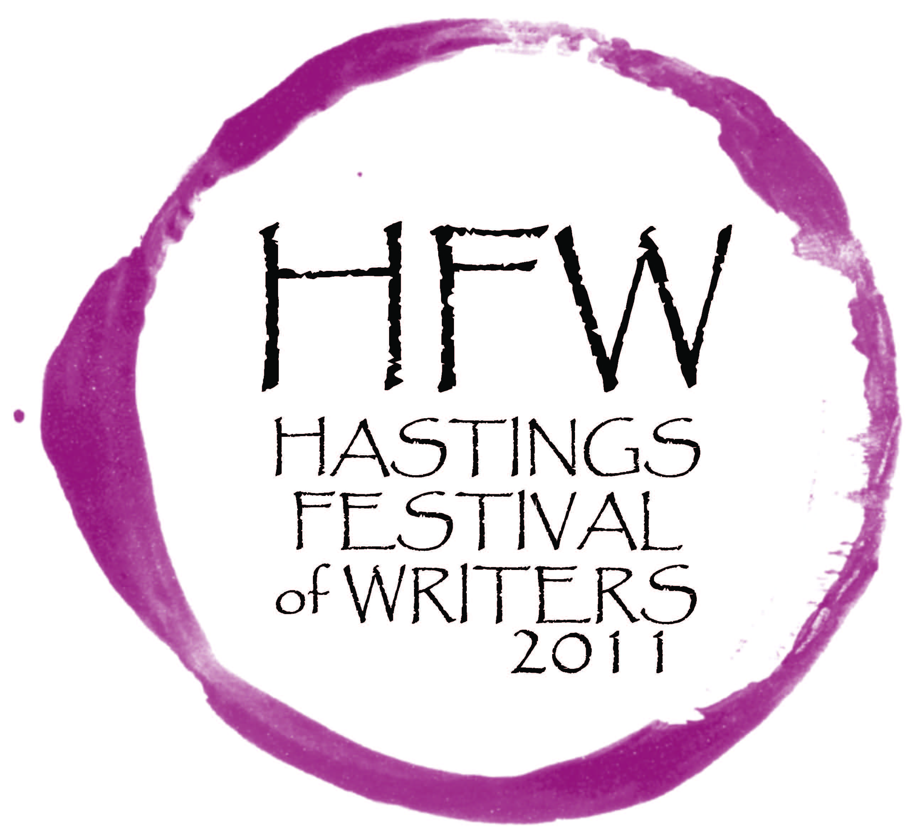
Date: Wednesday, Feb 23
Pages: TWO (includes programme)
Food, Wine and Words
Tickets are now available for the 2011 Hastings Festival of Writers for the weekend of 1-3 April.
While the writers change and events have evolved with each biennial festival since its beginnings in the barrel rooms of Te Mata Estate winery, the spirit of ‘food, wine and words’ remains constant.
Festival committee chairman Declan Eames says this spirit reflects the district hosting the festival, “Hawke's Bay is wine country and the connection between fine wine, fine food and fine words fits nicely in our enviable lifestyle.”
“We offer events where you can sit with friends, enjoying the Hawke’s Bay lifestyle, arts, culture and hospitality at its best.”
Deputy Mayor and Chairperson of Creative Hastings Cynthia Bowers says this year’s festival line up is absolutely exciting.
“There is a fine selection of New Zealand writers participating in the 2011 festival and to bring a Pulitzer-prize winning author such as Annie Proulx to this boutique Hastings festival is no small achievement,” says Cr Bowers.
“This is a tremendous opportunity for people to meet and hear writers of the highest calibre right here in Hastings.”
The festival weekend, beginning with a unique food and wine event at Clearview Estate in Te Awanga has a range of events to suit everyone, including free events held at the Hastings City Art Gallery and Havelock North Library during the day on Saturday.
More information on the festival is available on the Creative Hastings website www.creativehastings.org.nz

For more information, please contact organising committee member, Lizzie Russell.
Ph: 871 5095 Mobile: 027 322 2213 Email: lizzier@hdc.govt.nz

Festival Programme
Friday 1st of April.
Tickling our Senses
Clearview Estate - Starts promptly at 6pm
Join wine writer John Saker and food writer Hester Guy for an evening of fine food, wine and words. Delicious tapas-style morsels will be matched with Clearview’s award-winning wines, while guests are entertained by two of New Zealand’s favourite food and wine personalities.
Saturday 2nd of April
‘A Conversation with Cilla McQueen’
Hastings City Art Gallery in Civic Square at 10.30am.
Chaired by local poet Marty Smith.
Free entry.
McQueen is the current New Zealand Poet Laureate and her latest published collection is The Radio Room.
‘A Conversation with Annie Proulx’
Hastings City Art Gallery in Civic Square at 12noon
Chaired by author of the Denniston series, Jenny Pattrick.
The Pulitzer-prize winning writer will be in New Zealand to promote her recently-published memoir, Bird Cloud, and to conduct research for a potential future work.
‘A Conversation with Owen Marshall’
Havelock North Library at 2pm
Chaired by Lizzie Russell
For the final hour-long session, the action moves to the Havelock North Library on Te Mata Road. Senior New Zealand short story writer and novelist Owen Marshall will speak with one of his former creative writing students, Lizzie Russell.
‘An Evening of Pleasure’
The Assembly Room at Hawke’s Bay Opera House at 8pm
Chaired by Marty Smith.
Annie Proulx, Cilla McQueen, former Te Mata Poet Laureate Jenny Bornholdt, Owen Marshall and Jenny Pattrick will come together for an engaging evening.
Sunday the 3rd of April
‘Faultlines’
Pipi Restaurant in Havelock North at 10.30am
Wellington writer Kirsten McDougall will host the event.
The final event of this small, perfectly-formed festival will be a brunch with writers at Pipi Restaurant in Havelock North. This is a chance to enjoy famous Pipi food and hospitality, while sharing a more intimate session with Jenny Bornholdt, Owen Marshall and Jenny Pattrick.
Tickets for ‘Tickling our Senses’, ‘An Evening of Pleasure’ and ‘Faultlines’ are available through TicketDirect. www.ticketdirect.co.nz or ph 0800 4 TICKET (0800 224 224)

