**Hawke’s Bay**

**Central Hawke’s Bay, Hastings and Napier**

**Labour Market Mapping Report**

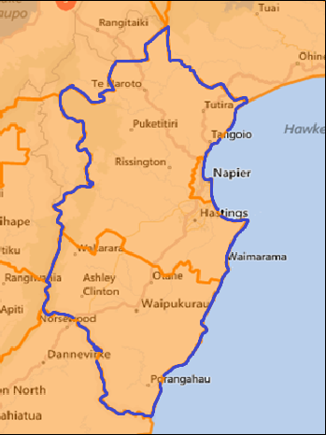

**STAKEHOLDER FORUMS**

Contents

About this report 4

Executive Summary 5

Demographics 6

State of the Labour Market 8

Demand for Labour 14

Supply of Labour 16

Opportunities 20



As a result of the Memorandum of Understanding with the government and the Mayors Taskforce for Jobs and the resulting partnership with the Ministry of Business, Innovation and Employment (MBIE) I am pleased to present this report.   The Taskforce and MBIE gathered this information through a series of meetings with Mayors and local Economic Development Agencies and the statistics available to the Ministry.

The Mayors' unique position in communities has enabled them to bring together key stakeholders to discuss the information and provide local, on the ground, in time, advice and recommendations to government about the support required to ensure regional economic growth and development and provide local jobs for local people.

Developing skills for local economies is key to the sustainability and vitality of communities and to improving outcomes for everyone but in particular our young people. It is clear in the report that we need to address this issue as a priority and see the relatively youthful population in the region as an extremely valuable resource, which must be nurtured, encouraged and enabled to participate fully.   The information contained in the report will assist our regions to make clear and confident decisions about the local labour market.

I am very pleased to see that the government wants to hear from our communities and I am confident the information gathered at our regional meetings will be invaluable to their decision-making with regards to allocation of resources to our regions.

Yours sincerely



**Mayor Dale Williams [Otorohanga]**

**Chair**

**Mayors Taskforce for Jobs**

# About this report

This report provides a summary of the Hawke’s Bay, specifically Central Hawke’s Bay, Hastings and Napier labour markets, to provide a context for discussions about economic development.

It was prepared as a result of the partnership between the Ministry of Business, Innovation and Employment (MBIE) and the Mayor’s Taskforce for Jobs (MTFJ). This partnership aims to maximise opportunities for local and regional economic development, skills, employment and innovation by gathering better intelligence on regional economies and improving the quality of regional information.

The report is, in part, designed to improve decision making capability, particularly around the investment and priority of effort of government agencies and local councils. It is also intended to better inform employers, education providers, Iwi Māori and other regional stakeholders on the current and future shape of their labour market and the challenges and opportunities these present.

Stakeholder Forums

Stakeholder Forums are for employers, business owners, tertiary education providers and iwi to talk about their business needs, challenges and opportunities, labour and skills shortages, planning and investment and smarter ways of doing business. More importantly Stakeholder Forums will discuss how local and central government can help to boost local labour markets and regional economies into the future.

From the information and feedback generated by the forums, local specific target projects will be explored and designed. Such projects may include identifying how employers can be more confident in taking on new workers, as well as how local and central government can support businesses to be successful.

# ****Executive Summary****

Hawke’s Bay has a population of around 155,300 people. Hastings has the largest population of 75,600, followed by Napier with 57,800 and Central Hawke’s Bay with 13,400.

The Hawke’s Bay owes it economic strength to its rich natural resources, and its primary and manufacturing industries are the cornerstones of the region’s economy. Over the last 10 years primary production has been static and the manufacturing sector has shrunk. The largest employing industries in the Hawke’s Bay as a whole are agriculture, manufacturing, health care, retail trade and education. The Central Hawke’s Bay and Hastings are both very much dominated by agriculture and a manufacturing sector geared around processing the output of the agricultural industries. Meanwhile, Napier is dominated by services (e.g. retail, health and education) for the wider region.

Like many other regions in New Zealand, the Hawke’s Bay faces many of the demographic and skills challenges – a slow growing and ageing population, a loss of the working-age population especially those with higher skills, and high unemployment and beneficiary recipients.

Māori are important in the region, and their role will continue to grow as much of the region’s population growth will come from the faster growing Māori population, which will account for the majority of growth in the working-age population over the next two decades. It is therefore absolutely key to the region’s success to develop the talent of the young Māori population and secure pathways for their future employment. Notwithstanding that there are pockets of disadvantaged Māori, Māori are doing relatively well in the region. Encouragingly, Māori have higher levels of educational achievements than Māori nationally, there has been increased Māori participation in tertiary education, and Māori are showing good levels of participation in the Modern Apprenticeships Programme.

The region is having difficulties with seasonal labour shortages, and employers are also reporting skills shortages in some sectors (e.g. engineering, IT and computing). In the absence of action to address skills shortages, the situation will worsen in the future given the demographic changes.

Economic development opportunities for the Hawke’s Bay region rest on further developing its primary industries and associated manufacturing activities, and leveraging its current strengths to develop higher value-added businesses. Providing an environment that attracts and grows businesses and building the education and skills of its young people will be key to realising the full economic potential of the region.

# Demographics

Key Points

* Slow growing and ageing population across the region
* Increasing population concentration in more populous areas and towns
* Lower share of working age population than New Zealand overall
* Māori will account for the majority of growth in the working-age population over the next two decades.

Population and population change

Hawke’s Bay has a population of around 155,300 people. Hastings has the largest population of 75,600, followed by Napier with 57,800 and Central Hawke’s Bay with 13,400. Hastings and Napier’s populations have increased since 1996 at 11 and 5 percent respectively, whereas the population of the Central Hawke’s Bay has stayed unchanged. New Zealand’s population has grown by almost 19 percent over the same period.

Looking ahead the population of Hastings is projected to grow over the next two decades, the population of Napier is projected to stay fairly level, and the population of Central Hawke’s Bay is projected to decline slightly. The pattern of low overall growth and increasing concentrations in the more populous areas and towns is typical of much of provincial New Zealand.

Figure 1. Population projections for Central Hawke’s Bay, Hastings, Napier and New Zealand

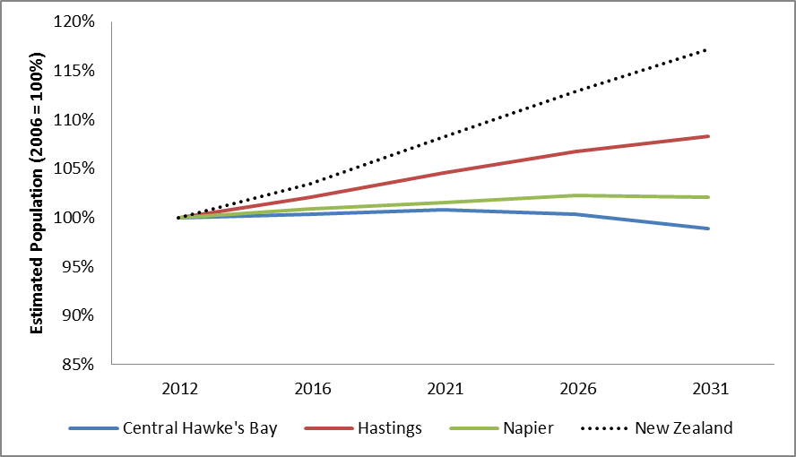

Source: Statistics New Zealand. The figure shows the medium projection by Statistics New Zealand.

Like New Zealand overall, the Hawke’s Bay has an ageing population. For the region as a whole the 0-14 age-group population is projected to decline by almost 7 percent till 2031, the 15-64 age group (working-age) population by almost 13 percent, and the 65+ population is projected to increase by 66 percent (Statistics New Zealand, 2013).

The current population is heavily concentrated in the over 50 age groups compared to the national average as shown in the population pyramid below (figure 2). This is particularly so in Central Hawke’s Bay, which has the highest concentration of the 50+ year olds. In addition, Hastings has a particularly high concentration of children and young people up to 19 years old. Moreover, the region has a lower share of working age people (20 – 50 years) than the national average, which is particularly pronounced in Central Hawke’s Bay. What is occurring is in effect a hollowing-out of the working age population as young people leave in pursuit of education or job opportunities elsewhere in New Zealand and overseas. The over-representation of those under 20 in Hastings is an important current strength that the region needs to capitalise on by ensuring those young people have access to education and employment that enables them to stay in the region and are equipped with the skills that employers need.

Figure 2. Population pyramid showing the population by age, gender and district, 2012

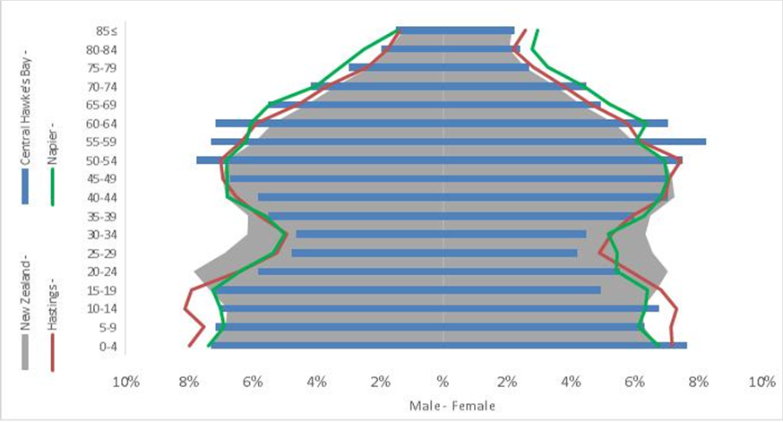

Source: Statistics New Zealand.

Ethnicity

The ethnic make-up of the Hawke’s Bay is somewhat different to the ethnic make-up of New Zealand overall, with Māori being more dominant. Māori are most dominant in Hastings, where they account for 21 percent of the population, followed by 19 percent in Central Hawke’s Bay and 16 percent in Napier. Nationally Māori account for 14 percent of the population.

Figure 3. Ethnic make-up of Central Hawke’s Bay, Hastings, Napier, and New Zealand

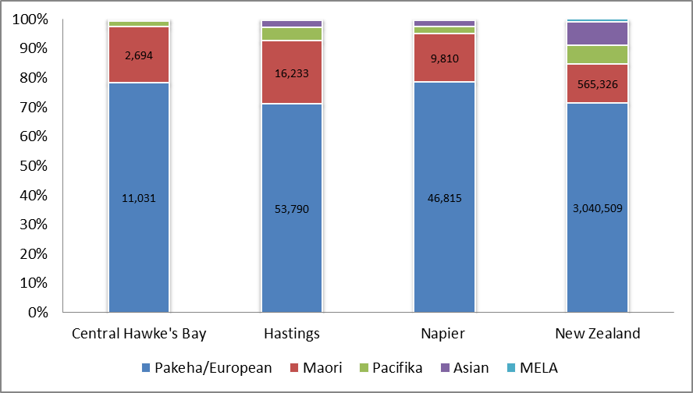

MELAAS

Source: Census (2006).

Note: MELAA refers to Middle Eastern, Latin American or African. European and Other Ethnicity includes persons who identify as New Zealanders.

The role of Māori will continue to grow in the region as much of the region’s population growth will come from the faster growing Māori population, while the European population is aging and increasing much more slowly. As such the majority of growth in the working-age population of the region over the next two decades will be from Māori. It will be absolutely key to the region’s success to develop the talent of the young population and secure pathways for their future employment.

The rohe of six iwi covers the Hawke’s Bay region: Ngati Kahungunu, Ngāti Pāhauwera, Ngati Kahungunu ki Heretaunga Tamatea, Maungaharuru Tangitu, Ngai Hineuru and Mana Ahuriri. At this point only Ngāti Pāhauwera has settled its historial grievances, which included financial redress of $20 million. The others are still at various stages of settlement with the Crown (Office of Treaty Settlemement, 2013). Eventual settlements are likely to provide potential investment sources.

# State of the Labour Market

Key Points

* The participation rate in the region is similar to the rate for New Zealand, but varies across districts
* The region has a higher unemployment rate than New Zealand, and it is highest in Napier
* Much higher rates of unemployment amongst Māori
* Higher than national levels of social benefit recipients in Napier and Hastings
* Higher than national levels of youth not involved in work or education
* Employment concentrations in primary production (agriculture and related manufacturing in food processing) in Central Hawke’s Bay and Hastings, and service industries in Napier providing services to the wider region.

Table 1 shows the labour market indicators for the three districts. The labour force participation rate, measuring the proportion of the working–age population who are either employed or unemployed, is slightly above the New Zealand rate for Central Hawke’s Bay and Hastings, and slightly lower in Napier.

The proportion of the working age population in employment is lowest in Napier, with a employment rate below the New Zealand average, whereas the employment rates in Central Hawke’s Bay and Hastings exceed the average rate for New Zealand.

The unemployment rate sits above the New Zealand rate of 6.8 percent[1] in Napier and Hastings with unemployment rates of 8.3 and 7.1 percent respectively. With a 6.3 percent rate of unemployment the Central Hawke’s Bay has the lowest unemployment in the region, which is also lower than the average unemployment rate for New Zealand. Māori unemployment is particularly high at 13.8 percent for the Hawke’s Bay as a whole.

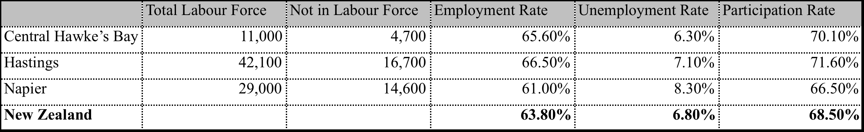Social benefit recipient numbers are higher in Napier and Hastings than nationally (figure 4). This is largely down to a higher number of people receiving the domestic purposes benefit than nationally. Central Hawke’s Bay has a slightly lower number of domestic purposes beneficiaries than nationally, but a higher number of unemployment benefit recipients than both Napier and Hastings, and New Zealand overall.

Source: Statistics New Zealand.

Table 1. Labour market indicators, year to September 2012

Unemployment benefit numbers tend to fluctuate seasonally throughout the Hawke’s Bay, particularly in Hastings, with peaks from August to October, and troughs around February. This is largely due to the seasonal nature of primary industries’ production cycle.

As a result of recent welfare reforms, Invalids Benefit and Sickness Benefit recipients are more likely to be work-tested than previously, which may mean that the population of job seekers becomes more diverse in terms of its needs for, for example, adjustable or limited hours.

Figure 4. Benefit Recipients (% of working age population), 2012

Source: Ministry of Social Development.

Youth Not in Education, Employment or Training (NEET)

Youth not in education, employment or training are considered to be disengaged from both work and education. The NEET rate, which captures this, is of interest due to the possible implications of being disengaged from work and education may have on the future labour-market experiences. Youth who are inactive for prolonged periods of time have heightened risk of poor outcomes, including lower earnings, greater reliance on social assistance and higher rates of unemployment. This is clearly of concern to the individuals involved, and more broadly high levels of disengagement reflect an underutilisation of human capital.

The NEET rate is not available for the Hawke’s Bay only, but includes Gisborne. The rate for the Hawke’s Bay/Gisborne area is consistently higher than the average for New Zealand. However, it is interesting to note that the gap has reduced recently. The Hawke’s Bay/Gisborne NEET rate peaked in 2010 after rising consistently for a number of years. Encouragingly it has dropped quite sharply since 2010. The reasons for this are not clear, but may include that they stayed in school longer because of the economic downturn, have left the region, or have entered education, training or employment.

The overall NEET rate and trend likely mask significant differences among ethnic groups (refer fig.5). At the nationwide level Māori NEET rates are more than double those of Europeans. It is reasonable to assume that this is the case in Hawke’s Bay/Gisborne too, and that the higher than national levels of disengagement is a reflection of the higher than national proportion of Māori population.

Figure 5. NEET rate (%) for youth aged 18-24 years, Hawke’s Bay/Gisborne and New Zealand

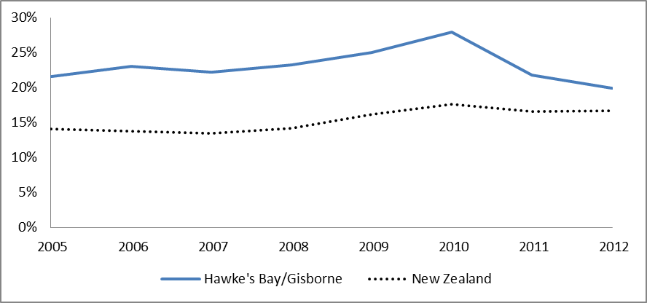

Source: Statistics New Zealand, Household Labour Force Survey.

Employment by industry

Table 1 shows the employment by industry in the Hawke’s Bay. It is clear that the primary and manufacturing industries are the cornerstones of the region’s economy. Over the last 10 years primary production has been static and the manufacturing sector has shrunk. The largest employing industries in the Hawke’s Bay as a whole are agriculture, manufacturing, health care, retail trade and education. The Central Hawke’s Bay and Hastings are both very much dominated by agriculture and a manufacturing sector geared around processing the output of the agricultural industries. Meanwhile, Napier is dominated by services (e.g. retail, health and education) for the wider region.

Table 2. Employment by industry, 2012



Source: Statistics New Zealand.

In the Central Hawke’s Bay the leading employing industries are agriculture, manufacturing, health care, retail trade and education. Agriculture and manufacturing are by far the dominant industries accounting for roughly 32 and 24 percent of employment respectively. The main agriculture activities are sheep and beef farming, as well as horticulture and viticulture. Manufacturing is dominated by food and beverage production. Manufacturing has contracted at a rate of 2.4 percent annually over the past 10 years, although over the past few years food processing is growing and a number of international firms has increased their processing capacity over the past years (REAR, 2013). The fastest growing employing industry has been the health care, which has grown by 3.3 percent over the past 10 years.

In Hastings the leading employing industries mirror those of the Central Hawke’s Bay – agriculture, manufacturing, health care, retail trade and education - although the dominance of agriculture and manufacturing is less so at 20 and 14 percent respectively. Both have contracted at 0.8 percent annually over the past 10 years. The fastest growing employing industry has been health care, which has grown by just over 3 percent.

Napier is largely dominated by the service industries. Retail trade accounts for 12.5 percent of all employment thereby making it the leading employing industry. Other service industries – health care, education and accommodation together account for another 28 percent of employment. Both the manufacturing and agriculture sector have shrunk over the last decade by just over 2 percent annually, and now account for 10 and 4 percent of employment respectively (Statistics New Zealand).

Central Hawke’s Bay, and to a lesser extent Hastings, are highly specialised driven by primary production, and heavily influenced by external factors such as commodity prices, exchange rates and drought. The Hawke’s Bay is currently being affected by the persistently high New Zealand dollar, as well as the drought that has hit many parts of New Zealand over the 2013 summer.

Industry change

Figure 6 shows the number of filled jobs in the leading industries in the Hawke’s Bay from 2002 to 2012. Manufacturing have suffered the largest drop overall although it has recovered slightly since 2011. Agriculture has fallen since 2009. Retail trade grew until 2007, but have since eased back to the same level as early 2000s. Education and training have had a slight upward trend over the period. Health care has shown consistent growth over the period.

Figure 6. Filled jobs in leading industries in the Hawke’s Bay region, 2002 to 2012

Source: Statistics New Zealand.

Figure 7 shows the number of employees in each region, and confirms that Central Hawke’s Bay has seen a large contraction in jobs with a decline since 2004, especially since 2006. A slow recovery has been seen since 2009. Hastings and Napier have both experienced growth in employment up until 2009, but have experienced a decline from 2009 to 2010, after which it has levelled out in Hastings and continued to decline at a lesser speed in Napier.

Figure 7. Number of employees by district, 2002 to 2012

Source: Statistics New Zealand.

Statistics New Zealand’s industry level forecast suggests that most of employment growth (63 percent) in the Hawke’s Bay over the next two years will come from growth in construction (26 percent), health and community services (13 percent), retail trade (10 percent), agriculture (9 percent), and food and beverage manufacturing (4 percent). While the data is not available on the types of occupational groups expected to be in more or lesser demand, it does provide some guidance, and certainly points to the importance of engaging with these industries to understand how best to align education and training to their businesses’ needs.

# Demand for Labour

Key Points

* Employers are having difficulties with seasonal labour shortages
* Employers are reporting skills shortages in some sectors, and these are likely to deepen in the future given the region’s demographic changes
* Occupations dominant in the Hawke’s Bay are in short supply of skills nationally.

Due to the seasonal demands of harvest, employers in the Hawke’s Bay are having difficulties with labour shortages for short periods throughout the year. This is currently the major labour shortage challenge facing the Hawke’s Bay.

In addition to the seasonal labour shortage, the region is facing a skills shortage in some industries. Employers are reporting difficulty finding people with engineering skills, as well as IT and Computing skills. The demographic challenges faced by the region (e.g. aging population, hollowing out of the working-age population, especially those with higher skills), combined with aspirations to diversity into higher-value added activities means that a skilled labour shortage is highly likely to deepen in the future. It will be vital for the future success of the region to address these challenges.

It is also worth noting that the current occupational mix (figure 8) in the Hawke’s Bay is highly dominated by the occupations in which employers nationwide are reporting the most difficulty in finding appropriately skilled workers (i.e. trade persons, managers and professionals) (Statistics New Zealand, Business Operations Survey 2012). The spread of occupations in Napier largely mirrors that of New Zealand overall with a large group in the professional occupations. Likewise the picture in Hastings is not too dissimilar, with the exception of labourers being much more dominant than nationally. In the Central Hawke’s Bay labourers, as well as managers and professional workers are the most prevalent occupations.

Figure 8. Employment by occupation, 2012

Source: Statistics New Zealand.

# Supply of Labour

Key Points

* High number of individuals with no or low levels of formal qualifications
* Educational attainment levels exceed national levels in Central Hawke’s Bay and Napier, but are lower in Hastings
* Māori are performing better than Māori nationally
* Disparities between Māori and Europeans in educational attainment
* Māori slightly over-represented in the Modern Apprenticeships Programme.

Highest Level of Qualification

The three districts have relatively high numbers of people with no levels of formal qualifications. Thirty percent of people in Central Hawke’s Bay hold no qualifications, and for Hastings and Napier the figures are 27 and 26.5 percent. This compares to 22 percent nationally.

The qualification profile of the Hawke’s Bay generally tends to be at the lower levels of the qualifications spectrum.

Figure 9. Highest qualification for individuals aged 15 years and over

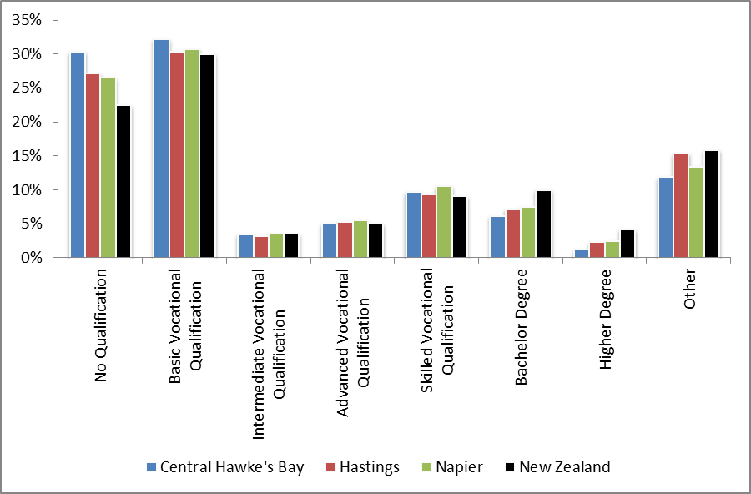

Source: Statistics New Zealand, Census 2006.

Educational Attainment

Educational attainment levels in the region as a whole are similar to national levels, but achievement levels do vary across the region (figure 10). Attainment levels are highest in Napier, where school leavers achieve above national averages on all three levels examined – NCEA 1 and 2, and University Entrance. Central Hawke’s Bay is similar in that there are higher achievement levels of NCEA 1 and 2, but they do have lower level of achievement for University Entrance. In Hastings on the other hand school leavers achieve at lower levels than nationally, but only marginally so.

The Government has a target that by 2017 85 percent of 18 year olds will have achieved NCEA level 2 or equivalent. Currently 70 percent of all school leavers in the Hawke’s Bay have achieved NCEA level 2 or higher, compared with 69 percent for the whole of New Zealand.

Figure 10. Achievement levels among all school leavers, 2011 (percentage of all students)

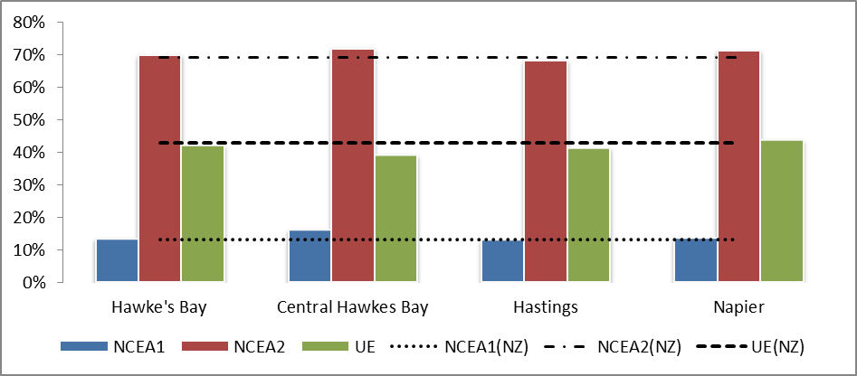

Central Hawke’s Bay

Source: Statistics New Zealand.

Figure 11 shows the educational attainment of Māori in the Hawke’s Bay region. Overall Māori are doing better than Māori nationally on all attainment levels, although the overall figures hide noticeable variations across the three districts. Māori in Central Hawke’s Bay and Napier are doing particularly well achieving at much higher levels of NCEA level 2 and University Entrance than Māori nationally. In Hastings, the picture is reversed with Māori achieving at lower levels than Māori nationally, except for NCEA level 1.

Figure 11. Educational attainment of Māori school leavers, 2011 (percentage of all Māori students)

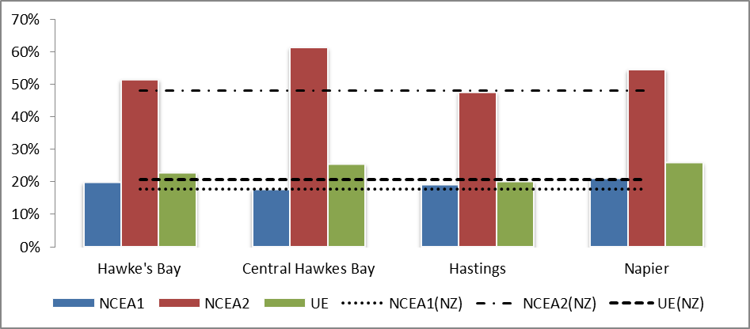

Central Hawke’s Bay

Source: Statistics New Zealand.

Figure 12 shows the educational attainment of Europeans/Pakeha in the overall Hawke’s Bay. Europeans/Pakeha are achieving at higher levels than Māori for NCEA level 2 and University Entrance, but they are achieving at lower levels than nationally for Europeans/Pakeha at University Entrance. This is the case in all three districts. In Central Hawke’s Bay and Napier higher percentages of students are achieving NCEA level 2 than nationally. Europeans/Pakeha in Hastings achieve at lower levels than nationally for Europeans/Pakeha.

Disparities between Māori and Europeans/Pakeha in educational attainment is common throughout New Zealand, and the same is the case in the Hawke’s Bay.

Figure 12. Educational attainment of European/Pakeha school leavers, 2011 (percentage of all European students)

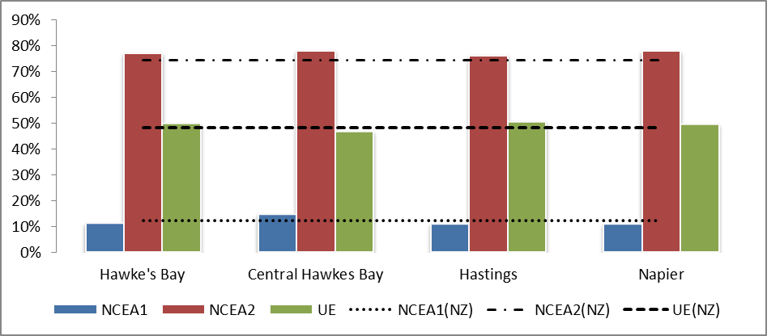

***Central Hawke’s Bay***

Source: Statistics New Zealand.

Modern Apprenticeships

Thirty two industries have been involved in the Modern Apprenticeships programme - a workplace-based workplace learning programme aimed at young people aged 16 to 21. Europeans make up the largest number of participants (71 percent) in the Modern Apprenticeship Progamme in the three districts, whereas Māori hold just over 25 percent of Modern Apprenticeships, which means they are over-represented in the programme since they make up about 19 percent of the total population in the three districts.

From 1 January 2014, the Modern Apprenticeships Scheme will be replaced by New Zealand Apprenticeships, which will provide the same levels of support, have a higher educational content and be available to all ages.

Essential Skills and Seasonal Employees

Immigration New Zealand’s Essential Skills policy facilitates the entry of appropriately skilled migrants to fill shortages. A relatively small number of migrants enter the Hawke’s Bay region via the Essential Skills category (282 migrants for the year ended March 2012, compared with 830 in the Bay of Plenty and 713 in Southland). The largest occupational group was professionals (38 percent of Essential Skills migrants, mostly health professionals), and 30 percent were technicians and trade workers (mostly food trade workers).

Horticulture and viticulture businesses in the region facing seasonal labour shortages are very supportive of the Recognised Seasonal Employer (RSE) scheme, where migrant workers complement New Zealanders, providing a secure supply of seasonal labour. About 15 percent of the seasonal labour requirements of the region are met through international seasonal work migrants including RSE workers.

Educational Providers

Eastern Institute of Technology (EIT) is the main education provider in the region. Its main foci are health (including nursing), management and commerce, education, society and culture, creative arts and engineering and related technologies, and some training in agriculture (including viticulture and horticulture). Teaching is delivered largely through its Taradale campus in Napier. EIT has a large range of degrees in additional to vocation and foundation diplomas and certificates.

EIT has good relationships with industry across the region. Unison Networks, a utility infrastructure company and one of Hawke’s Bay's largest employers, opened its Centre of Excellence training facility at EIT.

EIT has also enrolled 142 Hawke’s Bay students in its new trades academy in 2012 and 123 Youth Guarantee students. High Māori engagement in these programmes, including at higher certificate levels, is promising. Te Taiwhenua o Whanganui a Orotu (the local iwi authority in Napier), in partnership with WINZ and EIT, also runs a trade training programme for unemployed youth.

There are a number of private training providers in the region, including Workforce Development and G&H Training, which deliver mostly foundational level courses.

In the absence of a university in the region young people move to other parts of the country for university studies.

# Opportunities

Upskilling the Workforce, particularly Māori

The current educational achievement of Māori in the Hawke’s Bay is already above educational achievements for Māori nationally. Given the faster growing Māori population in the region, and the disparities between Māori and European/Pakeha in educational achievement, the region should continue to focus on lifting the skills of the Māori population. Encouragingly improvement has already occurred in this area. Not only do Māori in the region have higher levels of educational achievements than Māori nationally, but there has been increased Māori participation in tertiary education, and Māori are showing good levels of participation in the Modern Apprenticeships Programme.

Lifting the skill levels of the Hawke’s Bay workforce as a whole is an important lever available to business and other decision makers in the region. Skill levels are important not only for individuals, but also for the local economy. A shortage of higher qualifications among the local workforce may be constraining the ability of the region to attract and grow entrepreneurs and higher value-added businesses. Likewise a lack of jobs will tend to drive away the working-age population, particularly those with higher skill levels.

*Growing Businesses through Intensification and Diversification*

A significant opportunity is to intensify primary production, and capture more value from what it already produces through a move into higher value-added production. The major constraint on the region’s ability to intensify primary production is the availability of irrigation water. This is being addressed through the development of the Ruataniwha Water Storage project.

Diversification into other more knowledge intensive industries is also vital to boosting the performance and resilience of the region, which at present is heavily reliant on primary industries and processing sectors that are vulnerable to a range of external conditions and events.

There is already much evidence of the region seeking to increase innovation and productivity in the primary and manufacturing sectors, and to diversify and deepen the regional economy. This includes promoting productivity-enhancing tools and programmes; accessing government funding for innovation, primary industries and business capability development, engaging with CRIs and Massey University; and the recently announced establishment of the ICEHOUSE business incubator.

*Retaining and Attracting Young People*

There is increasing competition for skilled workers, both nationally and internationally, so the Hawke’s Bay region will need to compete with other regions for such workers. However, the Hawke’s Bay region, particularly Hastings has relatively high proportions of young people, including those still in school, who represent a great resource for the region. It will be important to retain school leavers and young people in the region by making the region attractive for young people and by continuing to build strong connections between schools, educational providers and industry to ensure smooth transitions and clear pathways into productive and relevant training and employment.

Building a more diverse regional economy will also naturally result in a broader range of employment options, which will assist the region in retaining its young people already there, as well as making returning a more attractive option for young people once they have completed tertiary studies elsewhere.

*Maori Settlements*

Given the younger and faster growing Māori population in the region, the future success of the region will depend significantly on the participation of Māori in the regional economy. There is potential for treaty settlements to enable Māori to become significant investors in the region, and strengthen their economic base. There is scope for government agencies and businesses to work with iwi to achieve mutually beneficial outcomes.

*Coordinated Effort*

Taking advantage of these opportunities outlined above will require the coordinated effort of all affected parties (i.e. central, regional and local government, Iwi, employers and education and training providers).

###### Central government strategies and actions

The Government has a renewed focus on regional development, and will work together with regional and local actors to tackle local challenges and leverage opportunities in order to build successful regions.

The Government’s Business Growth Agenda is a programme of work that will support New Zealand Businesses grow. It is focused on six elements needed for business growth: natural resources, skilled and safe workplaces, infrastructure, capital, innovation and access to export markets. Each of these has its own programme of work.

Actions relevant to the Eastern Bay of Plenty are:

* Māori Trades Training
* Lifting Māori school leaver achievement
* Increasing Youth Guarantee places
* Refocusing polytechnic sector on skills for regions
* Leveraging the cultural and asset base of Māori economy for growth
* Expand trades and services academies’ flexible school-based provision
* Development of New Zealand apprenticeships and apprenticeship reboot

###### Regional and local strategies and actions

The regional and local government landscape in the region is changing with the strong possibility of the amalgamation of the district councils.

The region has an economic development strategy, which was developed with input from councils, the private sector and the Hawke’s Bay Chamber of Commerce. The Hawke’s Bay Regional Council has led the recent refresh of the strategy, which has been released as the ‘Regional Economic Development Framework’. It includes actions around increased agency collaboration; resilient primary sector growth; visitor growth; business growth and investment attraction; and skills, capability and workforce optimisation.

The skills, capability and workforce optimisation actions, include ones aimed at retaining people and business, improving pathways to employment for young people, and identifying skills gaps and ways in which to address them. The work-stream is led by Business Hawke’s Bay together with Hastings District Council, Central Hawke’s Bay District Council and Ministry of Social Development. Training providers, employers, community groups, schools, councils, Iwi and EIT are all consulted as part of the process.

1. It is important to note that this is based on the quarterly HLFS results, the next results are due May 9th 2013.