Three Waters Reform
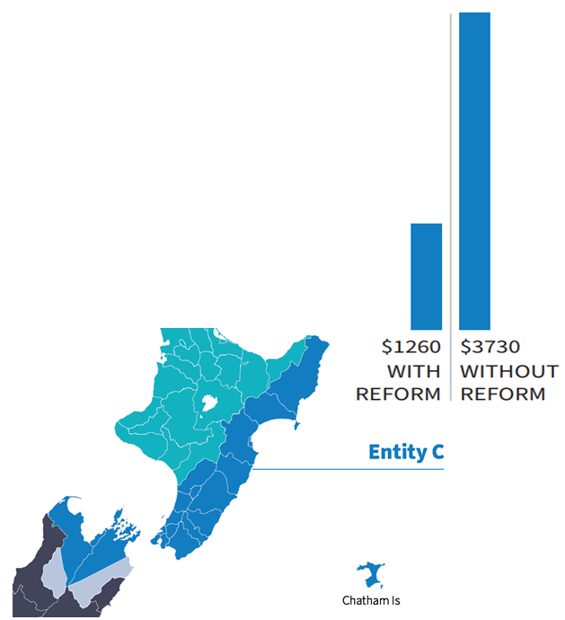
Hawke’s Bay
New Zealand’s council-owned drinking water, wastewater and stormwater services (three waters) are being rearranged into four publicly-owned water service entities to ensure all New Zealanders have access to safe, affordable water services that meet their expectations now and into the future.
From 1 July 2024, the Hawke’s Bay councils’ three waters services will be joined with councils across the east coast and the top of the South Island to form Entity C.
What will this mean for future affordability
Our three waters infrastructure requires a large investment over the next 30 years. Modelling predicts that by 2051 without reform, the average cost per household to deliver these services will increase to:
- $7,260 in Central Hawke’s Bay;
- $4,530 in Hastings;
- $2,540 in Napier; and
- More than $8,690 in Wairoa.

With reform, costs are estimated to average $1,260 per year across Entity C areas by 2051.
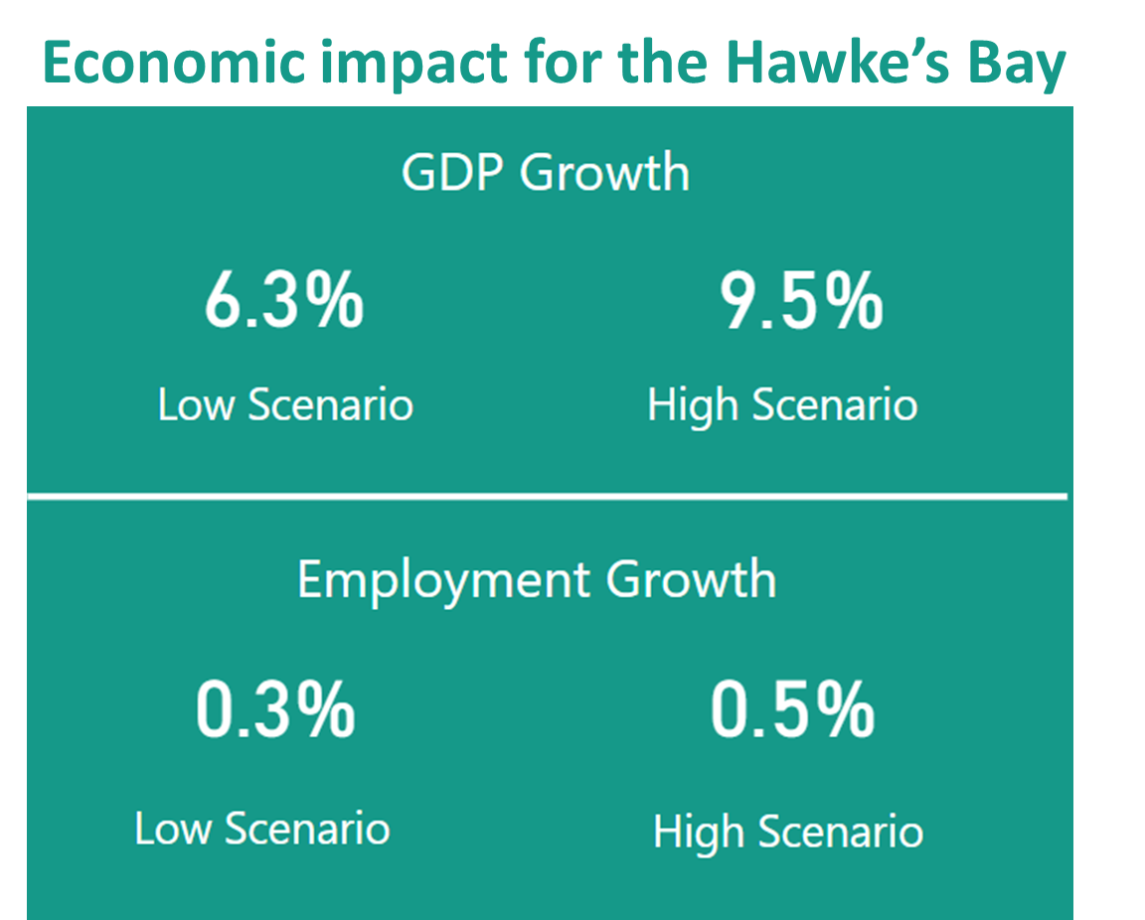
What will reform mean for local jobs and growth?
The three waters reforms are about ensuring communities can receive three waters services more affordably and efficiently.
Water infrastructure will require additional local employees to upgrade and deliver services. This is not about centralising jobs – pipes and infrastructure will still exist across the region, and people will be needed to maintain them.
For the Hawke’s Bay, the reforms are expected to see the regional economy grow by:
- an additional 246-367 full time equivalent jobs; and
- a 6.3%-9.5% GDP increase (or $577.2m – $866.7m in net present value terms)
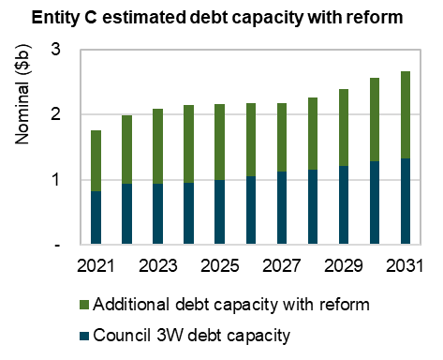
Why is this reform needed?
Many councils are at the upper limit of their ability to borrow to invest in critical three waters services. In addition to delivering these services more efficiently to communities, the reforms will unlock more investment into these services.
The graph to the right shows the additional borrowing capacity of the entity to invest in water infrastructure. Early modelling indicates that reform will unlock an additional $248 million for Hawke’s Bay councils to invest in their communities. This is in addition to the Government’s ‘better-off’ funding of $91 million.
The challenges facing councils in continuing to deliver these services alone are only going to worsen with climate change, growth and stricter regulation of quality standards. For some councils these challenges are already impacting communities, for other councils these are challenges communities will need to face in the coming decades.
In the Hawke’s Bay there has been a strong focus on drinking water safety following the Havelock North contamination event. However, with many of the regions wastewater treatment plants discharging to freshwater, reconsenting these systems to meet environmental standards and cultural expectations will become costly for these communities.

Find out more about the Three Waters Reform at: https://threewaters.govt.nz/

Appendix: Case for change
Additional borrowing capacity
Balance sheet separation from the entities is a core feature of the Government’s proposals for greater borrowing capacity, creating three waters investment through the entities, and allowing councils to invest in the wellbeing of communities. This would not be achieved in a Hawke’s Bay CCO model.
Early analysis is subject to further due diligence, but indicative analysis shows the borrowing capacity of Hawke’s Bay councils will increase by the following through reform:
- $45 million for Central Hawke’s Bay District Council
- $107 million for Hastings District Council
- $91 million for Napier City Council
- $5 million for Wairoa District Council
For those few councils that do not have an increase of borrowing capacity in the short term following the transfer, the Government has allocated a $500 million ‘no-worse-off’ support package.
Government support package
The Government has allocated $2 billion ‘better-off’ funding to councils to invest in community wellbeing following reforms. This includes:
- $11 million for Central Hawke’s Bay District Council
- $35 million for Hastings District Council
- $26 million for Napier City Council
- $19 million for Wairoa District Council
Ability to achieve benefits of scale through regional model.
- International evidence shows the optimum size of water entity is 600,000-800,000 connections.
- With just over 170,000 connections in the Hawke’s Bay (and Gisborne), a regional model falls far short of the scale necessary to achieve benefits.
- A regional model would still see household costs as high as $2,870 by 2051 compared to the collective Entity C which is projected to $1,260.
Compliance with drinking water standards in 2019-2020
- Three of the four the Central Hawke’s Bay District Council supplies failed to comply with all drinking water standards
- Three of the seven Hastings District Council supplies failed to comply with the protozoal standards
- One of the three Wairoa District Council supplies failed to comply with the Health Act and other drinking water standards
- The Napier City Council supply complied with the Health Act and other drinking water standards.
Wastewater treatment plants
In the Hawke’s Bay there are 10 wastewater treatment plants provided by councils. Of these plants:
- 6 discharge to freshwater and 3 discharge to the ocean.
- Only East Clive has publicly accessible monitoring information on the compliance with consents for these treatment plants.
- In 2019, one wastewater treatment plant was operating on expired consent, with a further three plants due to expire by 2029.
What is known about the network condition
Treatment plants have a large cost for replacement and reconsenting, and 80% of the asset value for maintenance and renewals is in the three waters pipe network.
In the Hawke’s Bay region, Napier and Hastings councils completed the Water New Zealand National Performance review. In this these, councils report their pipeline conditions as follows:
- Hastings, 17% of drinking water pipelines are in poor condition, and 9% of wastewater network is in poor condition.
- Napier, 42% of drinking water pipelines are in poor condition, 35% of wastewater network is in poor condition and 10% of the stormwater network is in poor condition.

Three Waters Reform programme support package information and frequently asked questions (dia.govt.nz)
Annual Report on Drinking Water Quality 2019-2020 (health.govt.nz)
Report-1-National-Stocktake-of-Municipal-WWTPs.pdf (dia.govt.nz)
Water New Zealand (waternz.org.nz)

