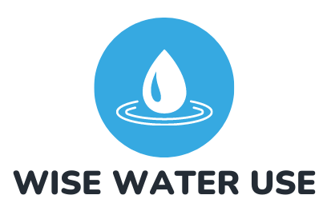
Hawkes Bay

PRESS STATEMENT

Friday 1 November 2024

Central Hawkes Bay mayor Alex Walker has conceded that she cannot promise that future costs associated with the Ruataniwha dam won’t hit ratepayers in the pocket.

For Immediate Release:

The concession was made during a live RNZ report (5:28) this morning.

“Wise Water Use HB has been warning there may be potential costs to ratepayers associated with this dam,” said spokesperson Dr Trevor Le Lievre, adding: “at last Mayor Walker has come clean on this issue.

“We have already highlighted costs for the maintenance of roads and bridges associated with the dam build, and then for ongoing removal of shingle from the dam reservoir. Ironically, Council still hasn’t repaired major roading infrastructure following Cyclone Gabrielle, including the Fletcher’s Crossing bridge on Wakarara Road which leads up to the dam-site itself!

“What other costs does our mayor envisage ratepayers might be on the hook for?” asked Le Lievre, citing the private company which operates the Opuhu Dam and which recently submitted on Environment Canterbury’s 2023-24 Long-term Plan seeking a targeted rate increase to fund capital works that irrigator-shareholders can’t afford: “Is this a possibility in Hawkes Bay?”

“Moreover, the question as to who will pay for the release of 20 Mm³ of dam water to maintain minimum flows in the Tukituki River – part of the greenwashing of the dam by promoters – still hasn’t been answered. We calculate that if this cost were to fall on Regional Council ratepayers this would entail a 30%+ rate increase.

“These potential costs should be of concern to the entire Hawkes Bay community, as this Trust, named the ‘Hawkes Bay Community Water Trust’, has been formed in their name.

A further concern to Wise Water Use HB is Mayor Walker’s consistent reference to ‘misinformation’ and ‘scaremongering’ concerning the trust, attributed to unnamed organisations.

“Certainly Wise Water Use attempt to argue on the available evidence, and welcomes informed debate. We have posted fact sheets on our website which has attracted a huge volume of traffic.

“It is unbecoming of the mayor’s high office for Mayor Walker to be alleging misinformation without actually citing what that information is. If Mayor Walker believes any of the information posted by Wise Water Use is incorrect we invite her to highlight which items, as we do aim to be factual,” said Dr Le Lievre.

Wise Water Use also believes that Mayor Walker and Chief Executive, Doug Tate may themselves be circulating incorrect information by steadfastly claiming that the purpose of the Trust is to explore wider-water security initiatives, of which the Ruataniwha dam is just “one of the tools in the kit”.

“Mayor Walker clearly hasn’t read Council’s own Trust Deed – its overarching purpose is to advance ‘the Scheme’, defined as the Ruataniwha dam. That was the instruction to Council’s lawyers when drafting the Deed, and they have certainly delivered. Why form a Trust to explore water security initiatives?

Wise Water Use understands that the dam promoters’ motivation for placing the consents and IP for the Ruataniwha dam into a community trust is to achieve the veneer of community buy-in, as a pre-requisite for attaining funding from the Regional Investment Fund.

“The dam promoters need that funding to pay for development of a new business case as the next step in progressing the dam under Fast Track. It’s really as simple as that,” said Dr Le Lievre.

A further concern is Mayor Walker’s consistent claim that there are sufficient environmental protections in place to ensure that the Ruataniwha Plains catchment will be protected from further nitrate leaching.

“As an environmental group we live and breathe this stuff, and we don’t agree that there are sufficient protections in place. Mayor Walker needs to spell out to the entire Hawkes Bay community what these environmental protections are, as the pollution that the Ruataniwha dam will cause won’t stop at the CHB border, but will be carried down the Tukituki River catchment all the way to Haumoana and then empty into our ocean,” finished Dr Le Lievre

ENDS.

For comment contact:
Dr Trevor Le Lievre (spokesperson, Wise Water Use HB)
M: 027 599 4888
E: contact@wisewateruse.org.nz

About Wise Water Use:
Wise Water Use is a grassroots environmental advocacy group dedicated to promoting sustainable water management practices and ensuring transparent decision-making processes in Hawke’s Bay. We work to protect the long-term interests of local ratepayers and safeguard the region's natural resources.

SUPPORTING INFORMATION

Insufficient Environmental Protections

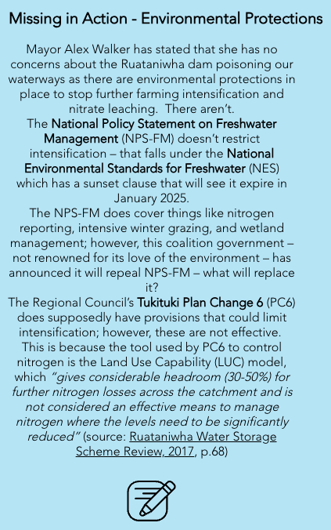
Source: Wise Water Use HB

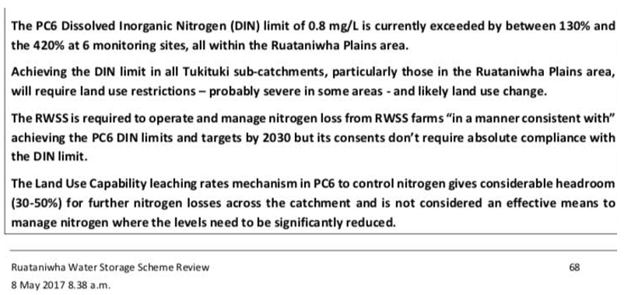

CHBDC Press Statement of 31 October2024

